Chapter 19, Solution 80.

Use PSpice to find the z parameters of the circuit in Prob. 19.7.

Chapter 19, Problem 7.

Calculate the impedance-parameter equivalent of the circuit in Fig. 19.71.

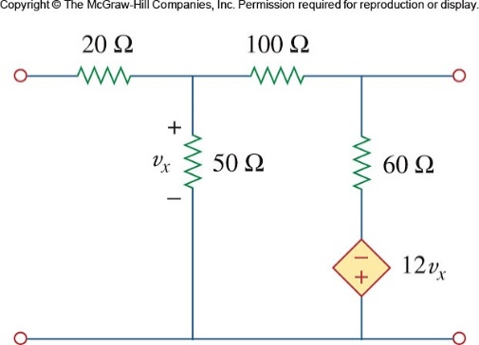

Figure 19.71
For Probs. 19.7 and 19.80.

Solution

To get z₁₁ and z₂₁, we open circuit the output port and let I₁ = 1A so that

The schematic is shown below. After it is saved and run, we obtain

Similarly, to get z₂₂ and z₁₂, we open circuit the input port and let I₂ = 1A so that

The schematic is shown below. After it is saved and run, we obtain

Thus,

